1. When you want to securely communicate between your Azure resources and

your on-premises network, what do you do?

Well, you use a VPN gateway, of course.

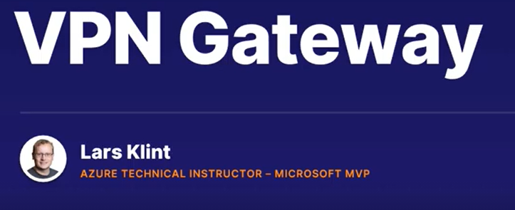

1. Before we get into the VPN gateway encryption magic, let's start with a virtual network gateway first.
2. A virtual network gateway is composed of two or more virtual machines that are deployed to a specific subnet you create, which is called the gateway subnet.
3. Remember, a subnet is a dedicated part of a VNet that has a specific range of IP addresses it can use. The VMs that are located in the gateway subnet are created when you create the virtual network gateway.

1. A VPN gateway is a specific type of virtual network gateway that is used to

send encrypted traffic between an Azure virtual network and an on-premises location over the public internet.

1. Let's say you have an established company that has its own on-premises infrastructure.
2. This is working well, but you are wanting to move parts of your system to the cloud to take advantage of the cloud goodness, such as scalability, high availability, and costs reduction.
3. This means you'll have a hybrid solution, with some of your data on-premises and some on Azure. In order to communicate securely between the two, you create a VPN gateway, which is a specific kind of VNet gateway.
4. A VPN gateway is a key part of having a secure and available hybrid cloud architecture.

There are various ways to connect your on-premises servers with the VPN gateway, but that is outside the scope of this course.

1. You should know the main three components of a VPN gateway setup though. An Azure VNet with a VPN gateway attached - this gateway will have its own public IP address - a secure connection called a tunnel, which has one of a number of encryption mechanisms, an on-premises network with a complementary gateway that can accept the encrypted data.
2. And this is called a site-to-site connection.

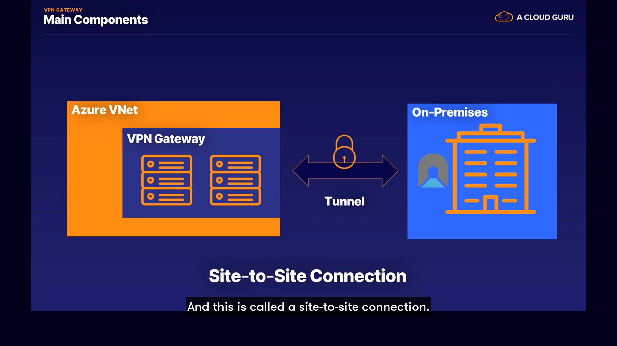

1. You can also have one VPN gateway with more than one on-premises network connecting to it.
2. This is called a multi-site connection.
3. For the exam, you need to know about VPN gateways as they are critical for efficient cloud computing in a hybrid architecture.
4. A VPN gateway is a specific kind of VNet gateway, which is two or more machines deployed to a specific subnet.
5. A VNet gateway of type VPN becomes a VPN gateway. And a VPN gateway is used to send encrypted data from Azure to on-premises.
6. There are three parts to a VPN gateway use case scenario. Azure gateway subnet of two or more machines, a secure tunnel for data to be transmitted, and an on-premises gateway to connect to as well.

